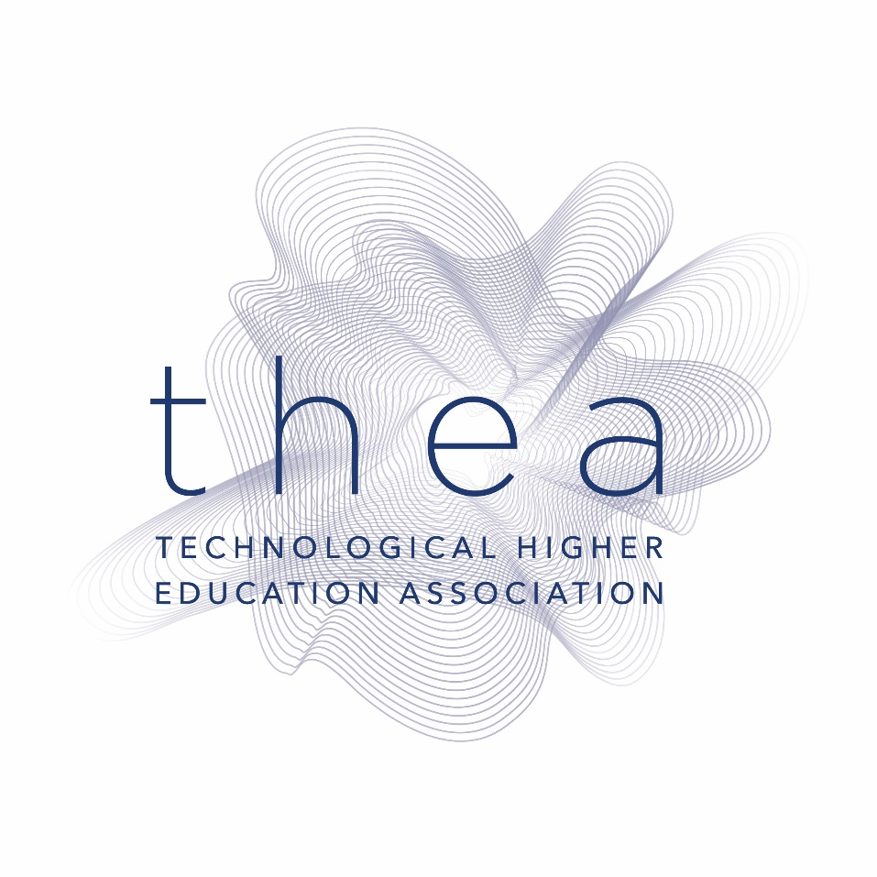

Submission to the review of the National Planning Framework 2040 on behalf of the Technological Higher Education Association (THEA)

September 2024

The Technological Higher Education Association (THEA) is the recognised representative body of the technological higher education sector, advocating on behalf of and supporting its members in achieving their aims and objectives. The THEA Council, comprising TU and IoT Presidents welcome this opportunity to provide their reflections on the National Planning Framework (NPF) and to propose key enhancements as part of the review process.

THEA recommendations for inclusion in the revised National Planning Framework 2040
THEA welcomes and supports the continued emphasis of the National Planning Framework (NPF) on balanced regional development. Our member institutions, including Technological Universities, have a strong record of accomplishments in driving regional economic development and are committed to enhancing their role going forward. It is in this context that THEA makes the following recommendation for inclusion in the NPF.

- The NPF should recognise the strategic importance of TU- (Technological University) led Regional Innovation Ecosystems (RIEs) in driving regional economic development. Regional sustainability is based on the delivery of solutions for society’s most pressing challenges (European Innovation Agenda, 5 July 2022). RIEs enable the regions to address global economic and social issues within the community and have a proven record of accomplishment of regional economic growth by focussing on actions and solutions which are customised to unique regional economic and social priorities. They support the development of regional specialisations. European research [1] indicates that RIEs enable SMEs/indigenous industries to be more innovative, create more jobs and register more international trademarks and patents than could be achieved alone. Furthermore, research has shown that RIE clusters are responsible for creating 25% of jobs within Europe. From the perspective of the NPF this recommendation supports the delivery of the National Strategic Outcomes 1,2,3 and 5.

- The NPF should identify the need to develop and enhance, not only physical infrastructure, but also knowledge infrastructure. For Ireland to build greater innovation capacity and output there must be a commitment articulated in the NPF to support advanced science, technology, skilled personnel, and to provide the necessary infrastructure to transform scientific and technological advancements into economic and social solutions. A commitment to creating regional knowledge infrastructures such as research facilities, startups, and innovation hubs is essential to improve access to, and output from, knowledge and talent that provides innovative solutions that build on disruptive technologies. Knowledge infrastructure has a key role in supporting the NPF in the delivery of 10 National Strategic Outcomes highlighted in the Plan.

- THEA welcomes the inclusion of student accommodation in the NPF. As noted by the National Student Accommodation Plan (NSAP), there is a significant unmet demand for on-campus and near-campus accommodation for students at all campuses of our higher education institutions. The absence of sufficient student accommodation within the Technological University sector promotes the flow of students out of the regions and inhibits the ability of the sector to attract qualified students and postdoctoral fellows into the region. This deficit has a direct impact on the availability of talent and knowledge for regional enterprises and undermines the attractiveness of the regions to national and international investors as centres of education, innovation, and knowledge generation. The NPF needs to highlight the strategic important of investment in student accommodation within the TU sector in support of balanced regional economic development. This recommendation speaks to National Strategic Outcomes 2,3,5 and 10 of the NPF.

- To bring together recommendations (I), (II) and (III) THEA proposes that a new enabling National Policy Objective is included that specifically relates to TUs. This Objective would set out the expectation of what TUs need to deliver in order for Ireland to achieve the ambitions of the NPF. For example, the policy objective could refer to the inability of TUs to borrow funds which inhibits the capability of TUs to delivery NPF ambitions regarding student accommodation, capital developments, collaborative projects with industry, student facilities, etc. Indicatively, this Objective would identify the requirement of TUs to:
  - drive regional development through continued investment in multi-campus Education and Training to increase skills labour and supply on a regional basis
  - create academic teaching facilities and campuses that attract national and international students of calibre
  - engage in competitive research and innovation that support regional development
  - develop skills, talent, and innovation capacity as a key strategic pillar for the NPF.

Context
The impact of the knowledge economy and the fourth industrial revolution surpasses that of the 1960s industrial revolution. The focus has shifted from mere economic development to encompass economic and social progress. We stand on the cusp of a technological revolution that will reshape our way of life, work, and interactions. This transformation, in its magnitude, breadth, and complexity, is unprecedented. Economically, we are moving towards a model based on sustainable, environmentally friendly products and services, rendering the old consumption-based model obsolete. Ireland's challenge is to maintain its economic position, which can only be achieved by promoting balanced growth throughout all regions. The nation is challenged due to its significant dependence on foreign investment for economic development and the lack of innovation and global integration among local enterprises. This challenge is further complicated by the need for Irish enterprises to shift towards a greener, environmentally sustainable economic framework in line with European policies. Additionally, Ireland's transition to a multicultural society introduces new social developmental issues across the regions. Over the coming years, Ireland must enhance access and inclusivity as every individual in Irish society is needed to contribute to, and should also gain from, the economic and social advancements linked to the emerging knowledge economy.
The Technological Universities (TUs) play a crucial role in achieving the primary goal of the National Planning Framework, which is to ensure an even distribution of social, cultural, and economic growth across all regions. Notably, in Ireland about 10% of decisions can be made autonomously by a region whereas the OECD average is closer to 20%, and many progressive countries are higher again. The result of this overly-centralised decision-making has been the continued unbalanced growth of the eastern region at the expense of the other regions (ref.: regional-investment-tracker-10-07-2024.pdf). One of the obvious consequences of this for the eastern region is the unaffordable or non-existent housing for those who work there.
The NPF looks to Technological Universities to contribute to wider regional development and to deliver greater opportunities to students within their regions, to institutions’ staff and to the broader local economy and society. Technological Universities act as a catalyst for regional economic development through their engagement with regional stakeholders in the creation of Regional Innovation Ecosystems (RIEs). The active collaboration between the university and local partners generates the education, innovation, and technologies needed to address global economic and social issues within the community. In particular, TUs play a vital role in fostering entrepreneurship and small and medium-sized enterprises (SMEs), ensuring that any increase in foreign direct investment occurs alongside a growing robust domestic industry that are partners in providing advanced services and products to global markets. TUs are embedded in networks of international universities and research institutes ensuring that excellence in teaching and research is benchmarked against international standards and that the outcomes of leading-edge international research can be integrated into Irish-based innovations and industry developments. As the international economic landscape becomes more uncertain, the National Planning Framework should draw on TUs and on TU-led Regional Innovation Ecosystems in addressing future economic and social challenges to deliver sustain regional economic and social growth.

THEA Observations on the National Planning Framework
The Technological Higher Education Sector applauds the fact that government has in place a planning framework that maps out a coherent public policy stretching out to the medium future. We acknowledge there are many demands, but there is a compelling case for building human capital capacity and talent that can deliver the ambitions of the NPF for strengthening social cohesion, increasing regional balance, developing environmental sustainability, and ensuring economic security. The TUs acknowledge their national responsibility to provide the foundational pillars - education, research, and innovation - that are strategically important and in fact key to delivering each one of these ambitions.
- The THEA higher education institutions (HEIs) embrace their responsibility to contribute to the realization of the ambition set out in the National Planning Framework. THEA notes the recommendations of the recent ESRI report that identifies the need to upgrade facilities in HEIs and suggests that a commitment to enhance higher education facilities is referenced in the revised NPF. (For example, TUs in Bundle 2 of the PPPs are waiting since 2016/2017 for new facilities with little or no public expenditure in educational facilities for the last 25 years). The commitments made for funding under TSSPF are acknowledged and welcomed. However, the implementation phase needs to be accelerated.
- Enhancement in digital infrastructure is also crucial to achieve policy goals in education.
- Both the government and regional communities look to TUs to play a significant role in strengthening rural economies and communities. The focus on ‘rural’ and ‘regional’ in the wording of the NPF is important and intentional – clearly, TUs are expected to strengthen rural economies through their own functions in the education and teaching of full-time and part time life-long learners and through research conducted with companies leading to innovative solutions in the regions in which the TUs are located.
- Technological Universities, located in every region including Dublin, are already making appreciable strides in delivering the objectives of the NPF strategy for urban and rural development. TUs are developing new organisational structures to create more effective cross-campus relationships to optimise the scope and effectiveness of regional education provision. A stronger focus on how the challenges of population growth and of addressing regional and environmental targets can be met, as set out in the current NPF, would be achieved if the role of TUs in this regard is referenced in the revised NPF.
- To enable the new technological universities to fulfil the objectives set out in the legislation, especially regarding the promotion of sustainable economic and social growth in the regions, a comprehensive long-term development strategy is essential. This strategy should emphasize enhancing capacity in postgraduate education, generating knowledge through both internal and joint research efforts, and sharing knowledge and innovative solutions through partnerships among regional entities, in line with the quadruple helix model [2].
- The revised NPF should make a clear commitment to build up an explicit counterbalancing Urban Arc along the South and West, of Cork-Waterford-Limerick Galway, as well of course of developing each of these Urban Cities in themselves. Specifically, we suggest that “Enabling the four cities to be regional drivers and to lead in partnership with each other and as partners in regional/interregional networks as viable alternatives to Dublin (NPF p. 15)” needs to be more explicitly stated to deliver a counterbalancing integrated Urban Arc in the South and West. For example, SETU is the only university in the south-east region serving a population of over 600, 0000. The full logical implication of “However it will be the combined potential of all four cities to be realised …, to create viable alternatives to Dublin… (NPF P. 15) needs to be brought out.
- The need for Ireland to grow economic areas outside of Dublin is well made in the NPF and is supported. This commitment needs now to be put into action. The absence in the plan for the development of the region north of a Dublin-Galway line needs also to be addressed. All the cities identified as ‘strong urban places’ are located along the Southern and South-West coast and the economic and social benefits arising from building up these cities will unlikely permeate beyond the immediate southern region without a concerted plan to develop a country-wide economic growth strategy. It would not be to the country’s benefit if regions and citizens of the north mid-lands and north-west are not engaged, and indeed left behind, as Ireland strives to stay competitive and to survive in the emerging global economy; we need to use all our most valuable resource – our people.

Conclusion
The Technological Universities can play a critical role in the delivery of the National Planning Framework by acting as a catalyst for regional economic and social development and driving to achieve balanced regional development. The TUs’ partnership with regional stakeholders provides the education, creativity, and technologies to address global economic and social challenges at regional level. This role can be enhanced through a concentrated and customised national strategy to support TU-led regional innovation ecosystems ensuring their alignment with Europe Innovation strategy such as smart specialisation and Europe Innovation Hubs. RIEs will attract ERD funding (similarly to TU-RISE) to drive regional growth in a consistent and sustainable manner across all regions. One route to how this might be achieved is proposed in Annex 1.

The significant under-provision of on-campus and near-campus accommodation for students is impacting on the attractiveness of Irish higher education institutions to Irish and international students. In fact, Irish students in HEIs in Ireland are at a significant disadvantage to many of their EU counterparts regarding availability of accommodation. In addition to meeting student needs and enhancing student experience, the provision of student accommodation would ease pressure on the private rental sector. As noted by the NSAP, “the impact of an additional 21,000 student accommodation bed spaces, in addition to an additional 1,500 Digs spaces, will free up at least an additional 5,000 rental units for the wider residential rental sector.” Mechanisms for how student accommodation might be provided are considered further in Annex 2.

Finally, THEA recommends that a National Policy Objective is incorporated that sets out the expectation of what TUs need to deliver in order for Ireland to achieve the ambitions of the NPF. In particular, in relation to regional development, student experience and building skills and generating talent and innovative solutions that support development across the regions.

Annex 1: Supporting Regional Innovation Ecosystems
One way to implement a strategy to create Regional Innovation Eco-systems is under the leadership of the key government departments with an oversight board composed of representatives of the Technological University, regional industry leaders, regional authorities and development agencies charged with the establishment of building targeted regional innovation ecosystems to foster economic and social growth through the application of new and emerging technologies and knowledge. Key target for the RIEs could include:

- The optimisation of the impact of national investment in the TUs for the benefit of the regional stakeholder's community
- Ensuring the active engagement of regional industry (particularly indigenous enterprises) in research, innovation, and technology to deliver internationally traded new products and service
- Collaborating with regional stakeholders to deliver new citizen centric sustainable solutions in areas such health care, transport, housing, and agriculture.

The key to creating RIEs is to enhance and focus the support for regional industry and to provide planned innovations and creative solutions to ensure Ireland remains globally competitive. There are already state and private agencies working in this space. It would be important, therefore, that RIEs draw on the existing activities of state agencies, innovation hubs and research facilities such that a concerted and coordinated approach is taken to supporting regional business partners.

Annex 2: Student Accommodation
In April 2024 the Taoiseach, Simon Harris, joined with the Minister for Higher Education Patrick O’Donovan, to announce that the government would be investing €100 million in developments that will deliver 1,000 student accommodation beds. These were concentrated on this occasion to three previously designated universities in and around the Dublin region. The Taoiseach stated:
“We must do everything we can to make college as affordable and as accessible as possible. No one should have to turn down a college place, or their dreams of pursuing higher education, because they can’t access an affordable bed.”
The statement is consistent with the government’s intention to make higher education accessible and to remove the barriers to education, be they financial or practical.
That sense of equity should be applied across the higher education sector. There is currently no borrowing framework in place for the technological university sector. Housing for All (2021), the government’s housing plan to 2030, contains a number of key actions relating to student accommodation, one of which involves the examination of a borrowing framework and financing options for the technological universities. Indeed, the plan states:
“The Government will support technological universities to develop purpose-built student accommodation where such a requirement exists, through access to appropriate financing.”
Section 21 of the Technological Universities Act 2018 provides for borrowing by Technological Universities subject to borrowing approval. The sector is working currently, and will continue to work, with D/FHERIS to advance this as the students in our institutions are significantly disadvantaged in that they don’t have access to dedicated student accommodation.
This disadvantage also extends to the capacity to attract and support international students. This deficit was highlighted during the recent Covid pandemic when the want of accommodation in the technological sector resulted in recourse to emergency accommodation which is inimical to Ireland’s valued reputation as quality destination for international education.
THEA welcomes the inclusion of student accommodation in the National Planning Framework (NPF). As noted by the National Student Accommodation Plan (NSAP), there is a significant unmet demand for on-campus and near-campus accommodation for students at all campuses of our higher education institutions. Delivery of Purpose-Built Student Accommodation (PBSA) will enhance the attractiveness of higher education institutions to Irish and international students and has the potential to ease pressure on the private rental sector. As noted by the NSAP, “the impact of an additional 21,000 student accommodation bed spaces, in addition to an additional 1,500 Digs spaces, will free up at least an additional 5,000 rental units for the wider residential rental sector.” The prioritisation of development of PBSA will have the twin effect of meeting that unmet demand, while also freeing up the private rental sector.
We note the reference in the NPF to the “adaptive reuse of existing buildings and brownfield sites for student accommodation” and we have some concerns about this being given undue priority. If those existing buildings and brownfield sites are unsuitable for private housing, social housing or refugee accommodation, it is difficult to see how they would be suitable for student accommodation.
THEA is pleased to see that the NPF acknowledges the contribution of students to financial, cultural, and social fabric of regions, cities, and towns. It should also be noted that the provision of on-campus and near-campus student accommodation is an important exemplar to our students of the positive benefits of sustainable living.
Given the positive contribution that student accommodation makes to sustainability, to the vibrancy of towns and cities and to the positive experience of students themselves, as well as the differential nature of the accommodation (to be expressed in new guidelines for student accommodation), we believe that it deserves its own inclusion as a separate National Policy Objective. We therefore propose the following for inclusion in the NPF:
National Policy Objective 46A
Provide for the development of on-campus and near-campus Purpose Built Student Accommodation to support and enable students to attend higher education and to contribute to the financial cultural and social fabric of regions, cities and towns acting as exemplars for sustainable living for future generations.

[1] https://single-market-economy.ec.europa.eu/industry/cluster-policy_en
[2] Carayannis, Elias G., and David F. J. Campbell. 2009. “Mode 3” and “Quadruple helix”: toward a 21st century fractal innovation ecosystem. International Journal of Technology Management 46(3/4): 201–234.

This additional NPO could sit well immediately after NPO 42 in the National Planning Framework and complement the language in bold there, relating to Technological Universities.

